《移动开发技术》实验报告
实验室：经技楼319 | 实验日期和时间：2022年5月24日 10:00-11:40
班级： 计科二班 | 学号：19114801 | 姓名： 刘爱兵
成绩及教师评语：

实验 ：
- 实验题目：移动模拟器的HBuilder环境配置和（猜数字）游戏项目的移动调试

- 实验目的：
1.进一步掌握首页页面布局相关部件的使用。
2.底部选项卡关联页面JS动态切换实现。
3.iconfont外部图标的使用（非.js）。

三．实验步骤（粘贴主要代码或运行截图，图不要太大，根据内容剪裁后再粘贴）
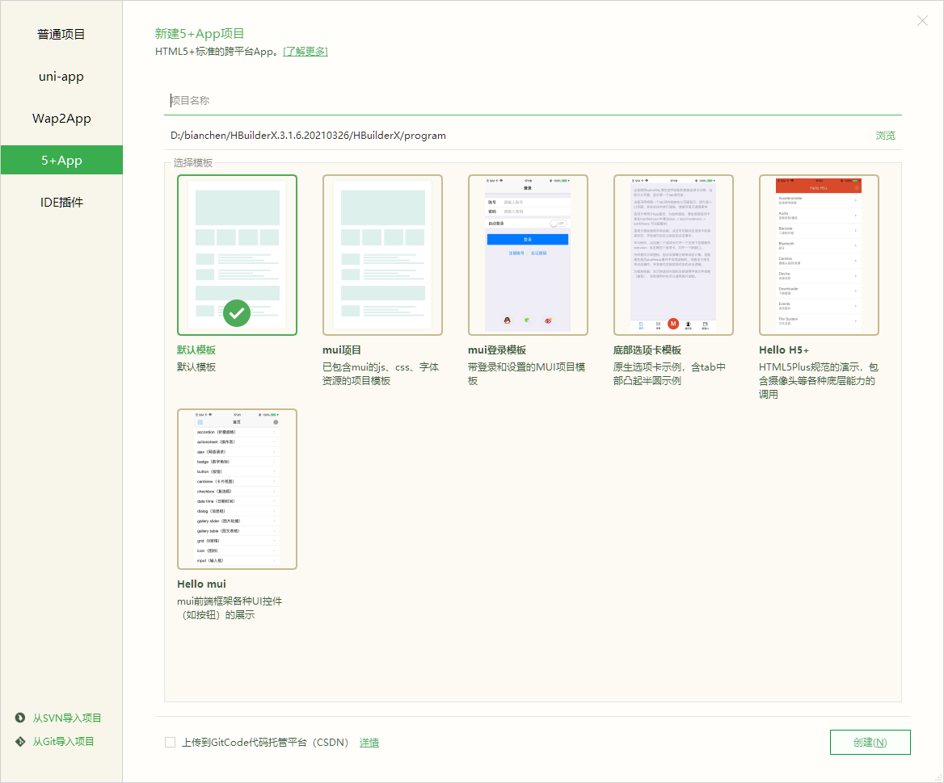
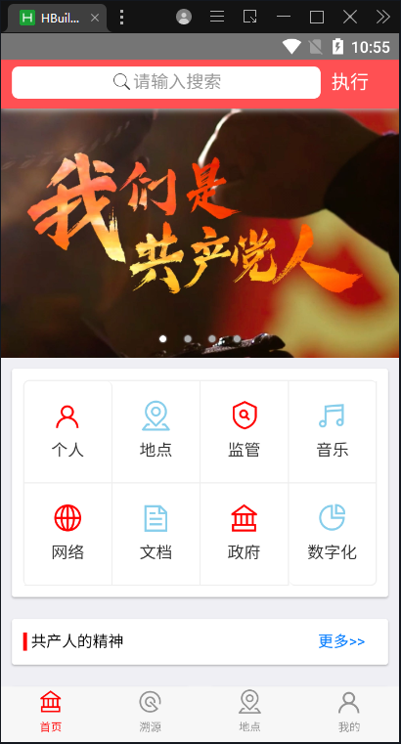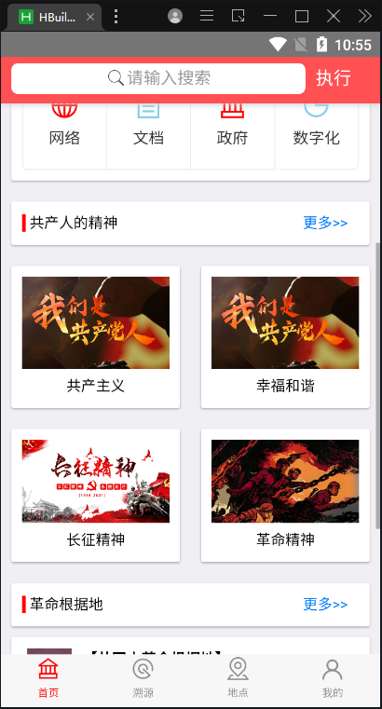
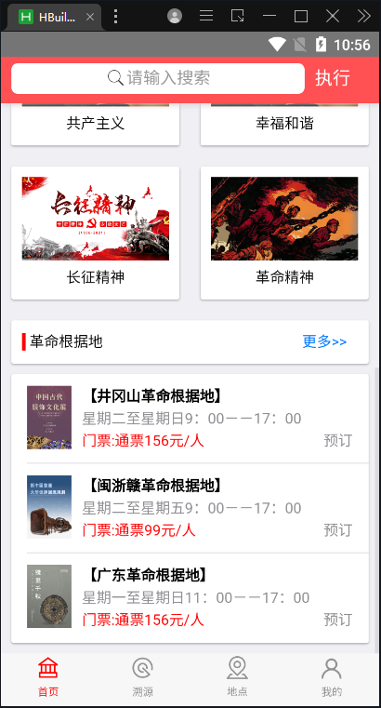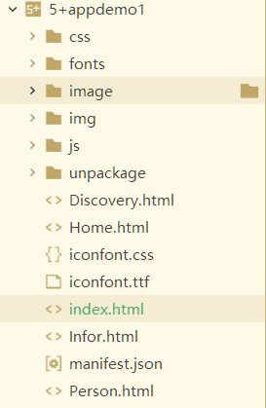

- 在设计和调试程序时我遇到的主要问题及其解决方案：

答:调试的过程中碰到图片大小不匹配的问题，在请教老师和百度之后解决了，下载相同大小样式的图片就可以解决图片样式不对的问题。

五．本次实验总结：
答：本次实验学会了使用底部选项卡关联页面JS动态切换实现，并且进一步掌握首页页面布局相关部件的使用。学习了更多iconfont外部图标的使用。

九．附录：（源程序代码）

<!DOCTYPE html>
<html>
<head>
<meta charset="utf-8">
<meta name="viewport"
content="width=device-width,initial-scale=1,minimum-scale=1,maximum-scale=1,user-scalable=no" />
<title></title>
<script src="js/mui.min.js"></script>
<link href="css/mui.min.css" rel="stylesheet" />
<link rel="stylesheet" href="./iconfont.css">
<script type="text/javascript" charset="utf-8">
mui.init();
</script>
<style type="text/css">
.cardtext {
margin-left: 30%;
}

input::-webkit-input-placeholder {

color: #aab2bd;

}

a:hover {
background-image: linear-gradient(120deg, #a1c4fd 0%, #c2e9fb 100%);
}

.mui-media-body {}
</style>
</head>
<body>

<header class="mui-bar mui-bar-nav" style="background-color: #FF5053;">
<div class="mui-input-row mui-search" style="width: 82%;float: left;">
<input type="search" class="mui-input-clear" placeholder="请输入搜索" style="background-color: #FFFFFF;">
</div>
<span style="display:inline-block;margin:10px 10px; color: #FFFFFF;">执行</span>
</header>

<div class="mui-content">

<div class="mui-slider">
<div id="slider" class="mui-slider">
<div class="mui-slider-group mui-slider-loop">
<!-- 额外增加的一个节点(循环轮播：第一个节点是最后一张轮播) -->
<div class="mui-slider-item mui-slider-item-duplicate">
<a href="#">
<img src="img/1.jpg">
</a>
</div>
<!-- 第一张 -->
<div class="mui-slider-item">
<a href="#">
<img src="img/1.jpg">
</a>
</div>
<!-- 第二张 -->
<div class="mui-slider-item">
<a href="#">
<img src="img/2.png">
</a>
</div>
<!-- 第三张 -->
<div class="mui-slider-item">
<a href="#">
<img src="img/1.jpg">
</a>
</div>
<!-- 第四张 -->
<div class="mui-slider-item">
<a href="#">
<img src="img/2.png">
</a>
</div>
<!-- 额外增加的一个节点(循环轮播：最后一个节点是第一张轮播) -->
<div class="mui-slider-item mui-slider-item-duplicate">
<a href="#">
<img src="img/1.jpg">
</a>
</div>
</div>
<div class="mui-slider-indicator">
<div class="mui-indicator mui-active"></div>
<div class="mui-indicator"></div>
<div class="mui-indicator"></div>
<div class="mui-indicator"></div>
</div>
</div>

<div class="mui-card" style="padding: 10px;">

<ul class="mui-table-view mui-grid-view mui-grid-9" style="background-color: #ffffFF;">
<li class="mui-table-view-cell mui-media mui-col-xs-3 mui-col-sm-3">
<a href="#">
<span class="iconfont icon-user" style="font-size:30px;color: red;"></span>
<div class="mui-media-body">个人</div>
</a>
</li>
<li class="mui-table-view-cell mui-media mui-col-xs-3 mui-col-sm-3">
<a href="#"> <span class="iconfont icon-didian"
style="font-size:30px;color: skyblue;"></span>
<div class="mui-media-body">地点</div>
</a>
</li>
<li class="mui-table-view-cell mui-media mui-col-xs-3 mui-col-sm-3">
<a href="#">
<span class="iconfont icon-jianguanfengkong" style="font-size:30px;color: red;"></span>
<div class="mui-media-body">监管</div>
</a>
</li>

<li class="mui-table-view-cell mui-media mui-col-xs-3 mui-col-sm-3">
<a href="#"> <span class="iconfont icon-yinle"
style="font-size:30px;color: skyblue;"></span>
<div class="mui-media-body">音乐</div>
</a>
</li>
<li class="mui-table-view-cell mui-media mui-col-xs-3 mui-col-sm-3">
<a href="#"> <span class="iconfont icon-wangluo" style="font-size:30px;color: red;"></span>
<div class="mui-media-body">网络</div>
</a>
</li>
<li class="mui-table-view-cell mui-media mui-col-xs-3 mui-col-sm-3">
<a href="#"> <span class="iconfont icon-wendang"
style="font-size:30px;color: skyblue;"></span>
<div class="mui-media-body">文档</div>
</a>
</li>
<li class="mui-table-view-cell mui-media mui-col-xs-3 mui-col-sm-3">
<a href="#"> <span class="iconfont icon-zhengfu" style="font-size:30px;color: red;"></span>
<div class="mui-media-body">政府</div>
</a>
</li>
<li class="mui-table-view-cell mui-media mui-col-xs-3 mui-col-sm-3">
<a href="#"> <span class="iconfont icon-shuzihua"
style="font-size:30px;color: skyblue;"></span>
<div class="mui-media-body">数字化</div>
</a>
</li>
</ul>
</div>
</div>

<div class="mui-card">
<div class="mui-card-content">
<div class="mui-row" style="padding: 10px;">
<div class="mui-col-xs-10" style="padding-right: 20px; ">
<div style=""><span style="background-color: red;">&nbsp</span>
共产人的精神</div>
</div>
<div class="mui-col-xs-2">
<a href="https://www.gov.cn/">更多>></a>
</div>
</div>
</div>
</div>

<div class="mui-row">

<div class="mui-col-sm-6 mui-col-xs-6">
<div class="mui-card" style="">
<div class="mui-card-content">
<div class="mui-row" style="padding: 10px;">
<img class="" src="img/1.jpg" style="width: 100%;">
<div class="cardtext">
共产主义
</div>
</div>
</div>
</div>
</div>

<div class="mui-col-sm-6 mui-col-xs-6">

<div class="mui-card" style="">
<div class="mui-card-content">
<div class="mui-row" style="padding: 10px;">
<img class="" src="img/1.jpg" style="width: 100%;">
<div class="cardtext">
幸福和谐
</div>
</div>
</div>
</div>
</div>
<div class="mui-col-sm-6 mui-col-xs-6">
<div class="mui-card" >
<div class="mui-card-content">
<div class="mui-row" style="padding: 10px;">
<img class="" src="img/3.jpg" style="width: 100%;">
<div class="cardtext">
长征精神
</div>
</div>
</div>
</div>
</div>

<div class="mui-col-sm-6 mui-col-xs-6">

<div class="mui-card" style="">
<div class="mui-card-content">
<div class="mui-row" style="padding: 10px;">
<img class="" src="img/4.jpg" style="width: 100%;">
<div class="cardtext">
革命精神
</div>
</div>
</div>
</div>
</div>
</div>

<div class="mui-card">
<div class="mui-card-content">
<div class="mui-row" style="padding: 10px;">
<div class="mui-col-xs-10" style="padding-right: 20px; ">
<div style=""><span style="background-color: red;">&nbsp</span>
革命根据地</div>
</div>
<div class="mui-col-xs-2">
<a href="https://www.gov.cn/">更多>></a>
</div>
</div>
</div>
</div>
<div class="mui-card">
<div class="mui-card-content">
<ul class="mui-table-view">
<li class="mui-table-view-cell mui-media">
<a href="javascript:;">
<img class="mui-media-object mui-pull-left" src="image/0.png" style="width: 100%;height: 60px;">
<div class="mui-media-body">
<span id="" style="font-weight: bold;">
【井冈山革命根据地】
</span>
<p class="mui-ellipsis">星期二至星期日9：00－－17：00</p>
<p class="mui-ellipsis"><span style="color: red;">门票:通票156元/人</span><span style="float: right;">预订</span></p>
</div>
</a>
</li>
<li class="mui-table-view-cell mui-media">
<a href="javascript:;">
<img class="mui-media-object mui-pull-left" src="image/1.png" style="width: 100%;height: 60px;">
<div class="mui-media-body">
<span id="" style="font-weight: bold;">
【闽浙赣革命根据地】
</span>
<p class="mui-ellipsis">星期二至星期五9：00－－17：00</p>
<p class="mui-ellipsis"><span style="color: red;">门票:通票99元/人</span><span style="float: right;">预订</span></p>
</div>
</a>
</li>
<li class="mui-table-view-cell mui-media">
<a href="javascript:;">
<img class="mui-media-object mui-pull-left" src="image/3.png" style="width: 100%;height: 60px;">
<div class="mui-media-body">
<span id="" style="font-weight: bold;">
【广东革命根据地】
</span>
<p class="mui-ellipsis">星期一至星期日11：00－－17：00</p>
<p class="mui-ellipsis"><span style="color: red;">门票:通票156元/人</span><span style="float: right;">预订</span></p>
</div>
</a>
</li>
</ul>
</div>
</div>

</body>

<script type="text/javascript">
var gallery = mui('.mui-slider');
gallery.slider({
interval: 5000 //自动轮播周期，若为0则不自动播放，默认为0；
});
</script>
</html>

<!DOCTYPE html>
<html>
<head>
<meta charset="utf-8">
<meta name="viewport"
content="width=device-width,initial-scale=1,minimum-scale=1,maximum-scale=1,user-scalable=no" />
<title></title>
<script src="js/mui.min.js"></script>
<link href="css/mui.min.css" rel="stylesheet" />
<link rel="stylesheet" href="./fonts/iconfont.css">
<style type="text/css">
.mui-active .iconfont,
.mui-active .mui-tab-label {
color: red;
}
</style>

</head>
<body>
<nav class="mui-bar mui-bar-tab">
<a class="mui-tab-item mui-active" href="Home.html">
<span class="iconfont icon-zhengfu" style="font-size:24px;display: block;"></span>
<span class="mui-tab-label" style="font-size:10px;">首页</span>
</a>
<a class="mui-tab-item" href="Infor.html">
<span class="iconfont icon-suyuan" style="font-size:24px;display: block;"></span>
<span class="mui-tab-label" style="font-size:10px;">溯源</span>
</a>
<a class="mui-tab-item" href="Discovery.html">
<span class="iconfont icon-didian" style="font-size:24px;display: block;"></span>
<span class="mui-tab-label" style="font-size:10px;">地点</span>
</a>
<a class="mui-tab-item" href="Person.html">
<span class="iconfont icon-user" style="font-size:28px;display: block;"></span>
<span class="mui-tab-label" style="font-size:10px;">我的</span>
</a>
</nav>
</body>

<script type="text/javascript" charset="utf-8">
mui.init();

mui.plusReady(function() {

var pages = ['Home.html', 'Infor.html', 'Discovery.html', 'Person.html'];

var show = plus.webview.currentWebview();
var contextstyle = {
top: "0px",
bottom: "50px"
};
for (var i = 0; i < pages.length; i++) {
var item = plus.webview.create(pages[i], pages[i], contextstyle);
show.append(item);
}
plus.webview.show(pages[0]);

mui(".mui-bar-tab").on('tap', 'a', function() {
var href = this.getAttribute("href");
plus.webview.show(href);
})

});
</script>
</html>

